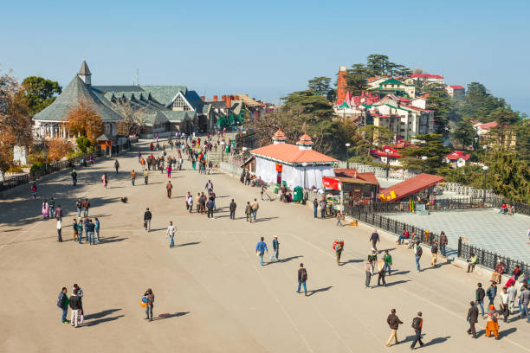
DAY 03: REACH CHANDIGARH

Shimla's Mall Road was developed around 1880 as an exclusive British leisure promenade when Shimla served as the summer capital of British India.
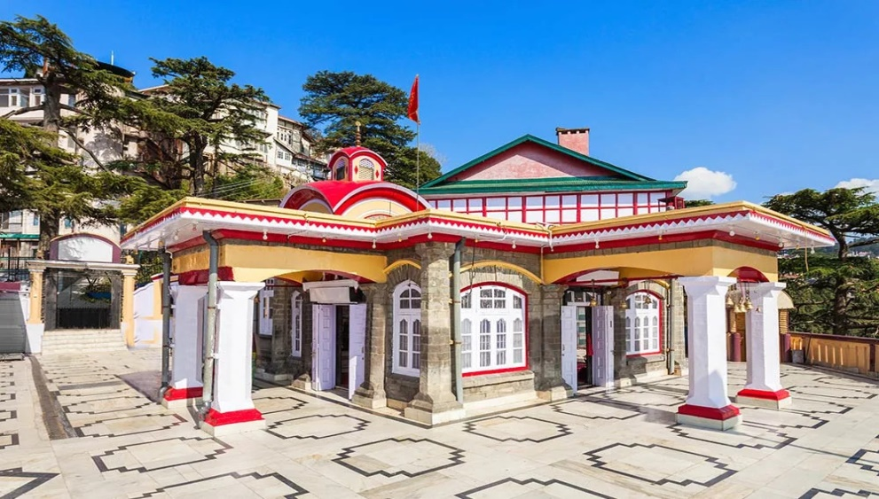

The Kali Bari Temple in Shimla was originally built in 1845 on Jakhu Hill by a Bengali Brahmin and saint named Ram Charan Brahmachari
DAY 04: AFTER BREAKFAST SIGHTSEEING at SHIMLA
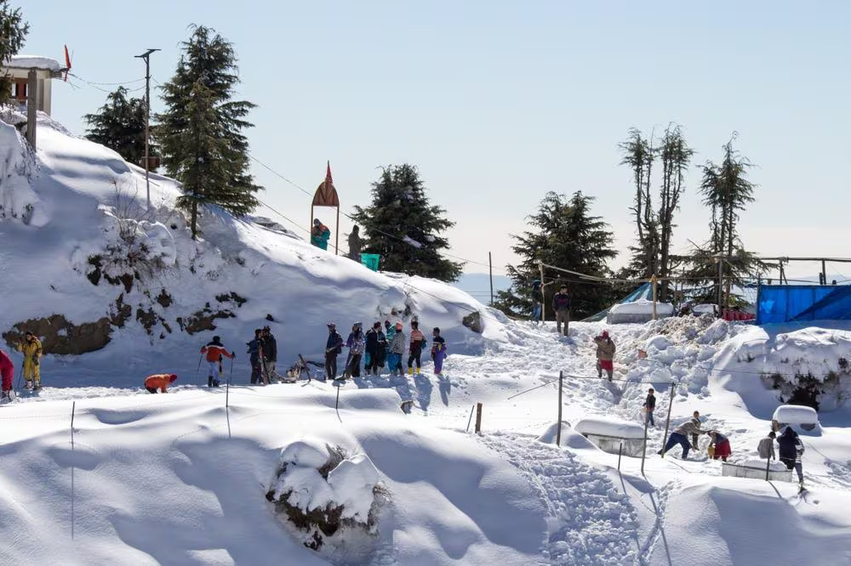

Kufri is a historic hill station located 20 kilometers from Shimla in Himachal Pradesh, founded and explored by the British in 1819.

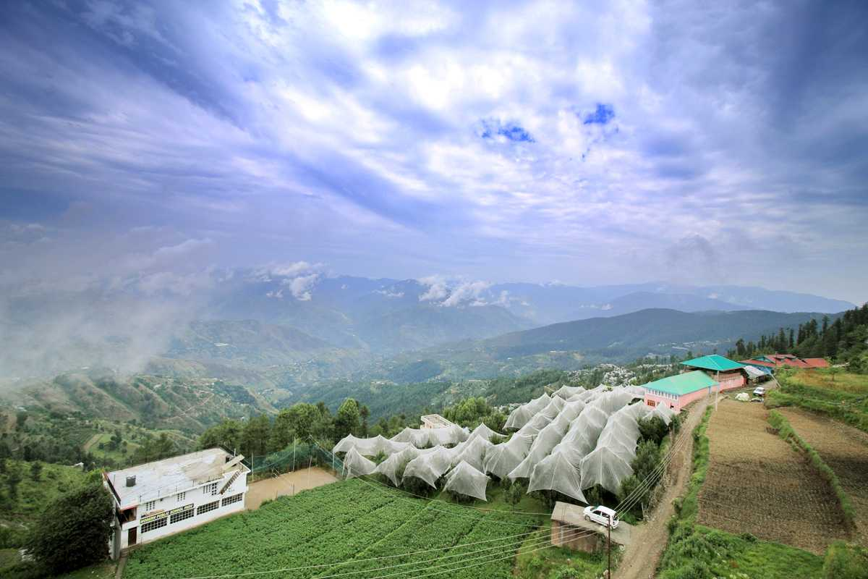

Fagu gets its name from the local word "fog" because thick mist covers the high-altitude hamlet for about nine months of the year
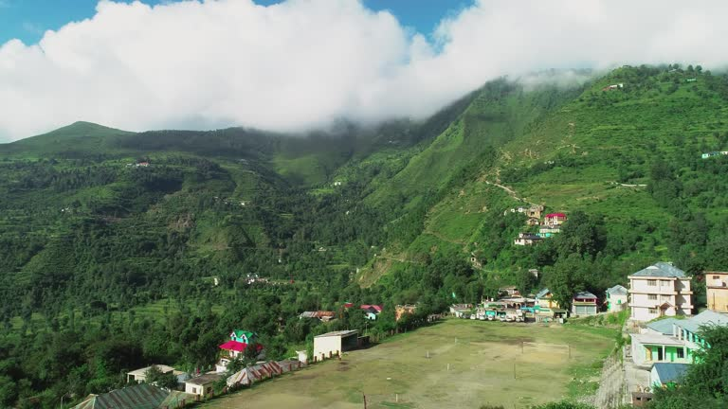

Green Valley in Shimla does not have a separate recorded political history, but it evolved from a dense, untouched Himalayan forest into one of the region's most famous scenic viewpoints during and after the British Raj.

DAY 05: AFTER BREAKFAST MOVE TO MANALI

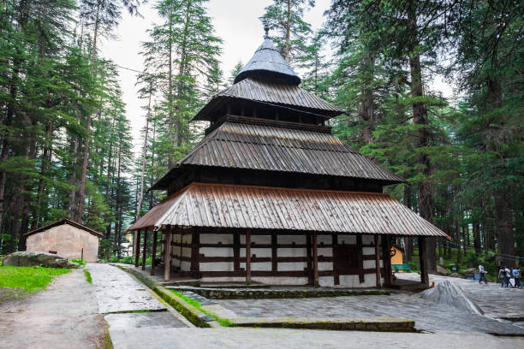
DAY 06: AFTER BREAKFAST LOCAL SIGHTSEEING AT MANALI

The famous Hidimba Devi Temple is located in Manali, Himachal Pradesh, rather than Shimla, and was built in 1553 CE by Maharaja Bahadur Singh.

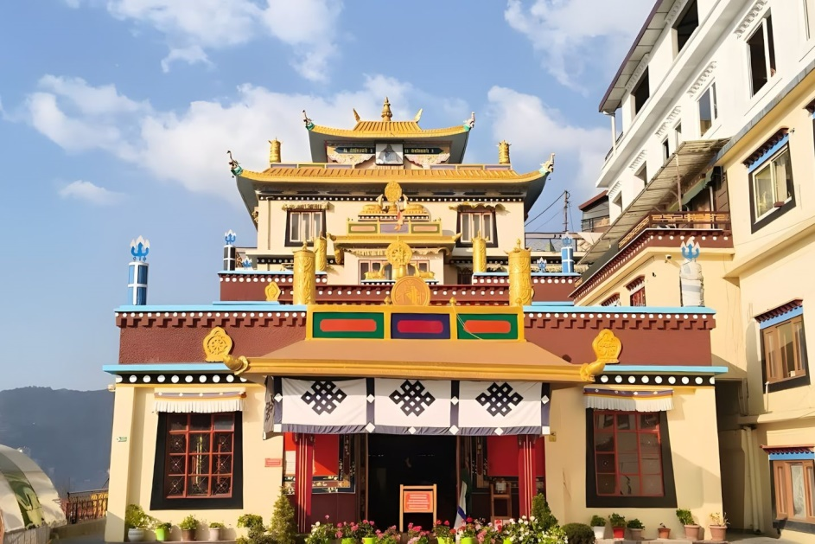

The Dorje Drak Monastery in Panthaghati, Shimla, was founded in 1984 by Kyabje Taklung Tsetrul Rinpoche to re-establish one of Tibet's original six "Mother Monasteries" of the Nyingma school after it was destroyed following the Chinese invasion.

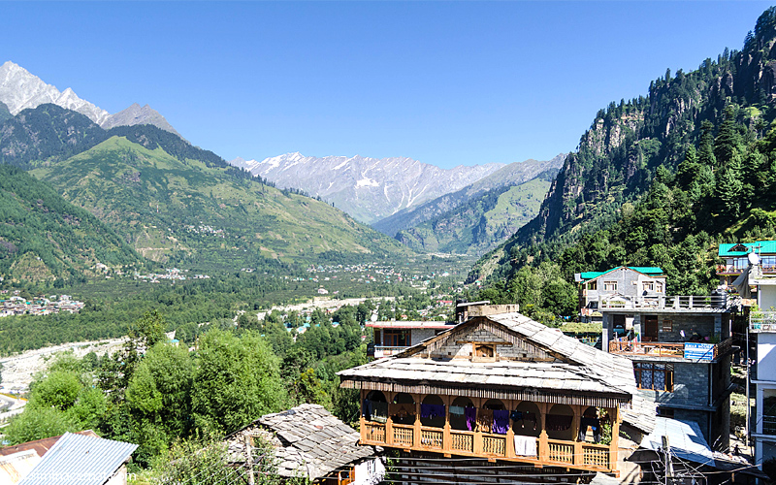

Vashisht is an ancient village located 3 kilometers from Manali in Himachal Pradesh, India, famous for its 4,000-year-old Vashisht Temple and natural hot sulfur springs

DAY 07: AFTER BREAKFAST SIGHTSEEING AT MANALI
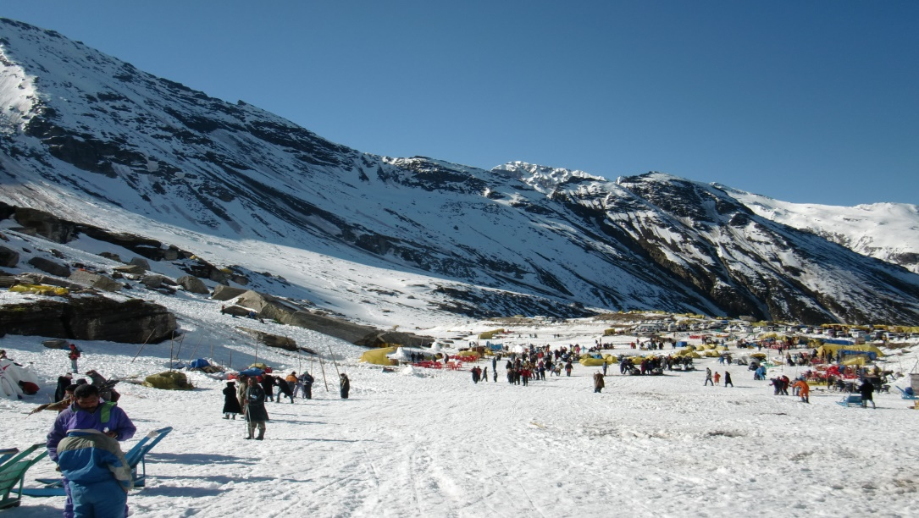

Rohtang Pass is a historic high mountain pass situated at 3,978 meters in the Pir Panjal range of Himachal Pradesh, connecting the Kullu Valley to the Lahaul and Spiti Valleys.

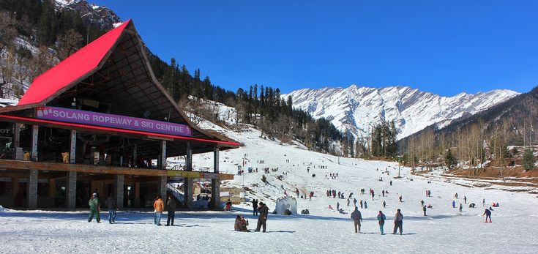

Solang Valley is an adventure sports hub near Manali, while Shimla is a historic colonial hill station located in a completely different district of Himachal Pradesh.

DAY 08: AFTER BREAKFAST MOVE TO MANIKARAN/BHUNTAR

DAY 09: AFTER BREAKFAST MOVE TO CHANDIGARH

